**Task 3**

Integrating docker host with Jenkins and deploying on tomcat server using docker container

to deploy war file on docker container in ec2 first integrate docker host with Jenkins

**1)Docker Host Machine:**

For that we need to create a docker user on docker host machine also we need to configure SHD files for password based authentication and then add that user into docker group

I have already install docker on **EC2** **Machine** so let's create a docker user before that we need to check whether group docker is available or not for that type

**#/etc/group**

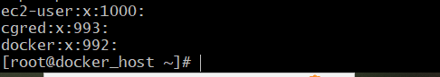

We can see who is readily available after installing docker on **EC2 Machine**

Now I will create a docker user as **dockeradmin** and add this user to **docker** group by using **usermod**

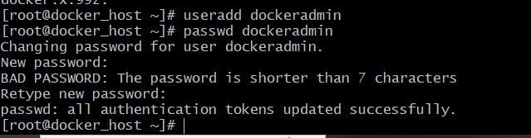



Then I will configure **sshd** file for **password based authentication** using Jenkins for that go to **ssh_config** file by using following command

**# /etc/ssh/sshd_config**

It will open up the file then search for password comment the password authentication no and an comment password authentication yes.

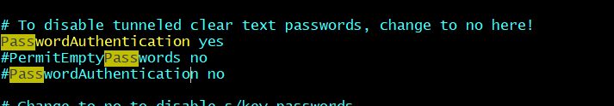

save the file and come out than reload the **SSD services** following command

**# service sshd reload**

**2) On Jenkins Server:**

Then go to Jenkins service after login go to **Manage Jenkins** in the available section search **For Publish Over** **SSH** plugin and click on **Install Without Restart.**

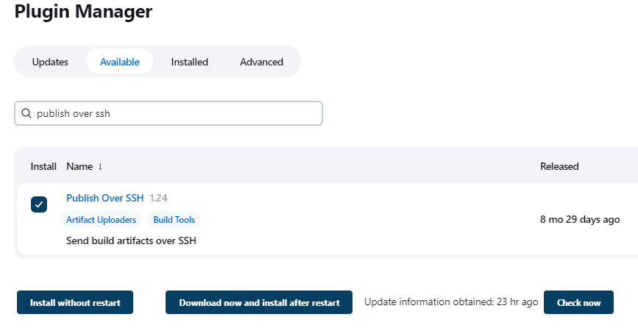

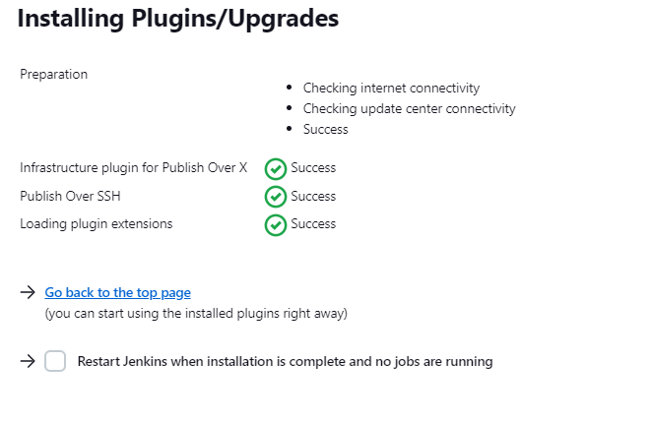

after installation again go to **Manage Jenkins** then go to **Configure System** option

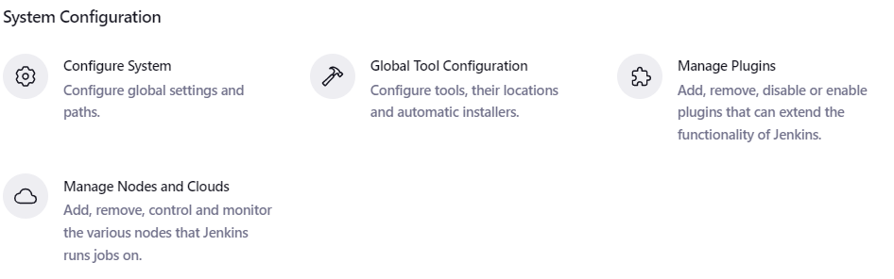

Go to **publish over ssh** session in the ssh server choose **add server** then provide name of server ,hostname as private IP of dockerhost and username that we have created on dockerhost machine as **dockeradmin**.

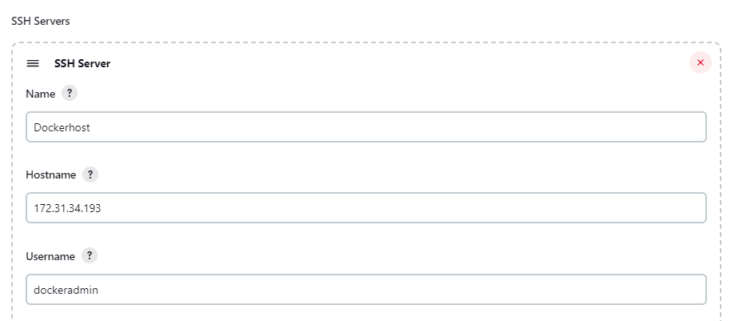

Then choose advanced option click the checkbox of **use password authentication** **or use a different key** option, provide password of dockeradmin user that we have created on docker host machine

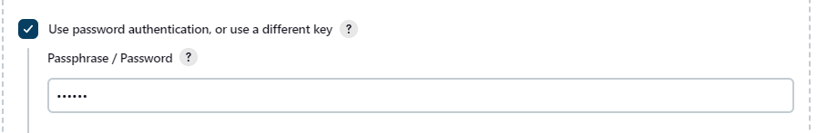

Then click on **Test configuration** button for checking whether our docker host is connected or not ,if its connected it will give output as success as shown in below images

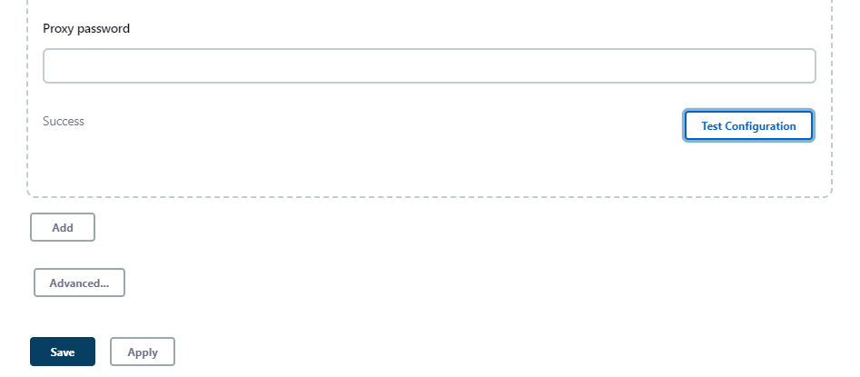

**3) Again go to your docker host machine:**

Create a directory for maintaining your **dockerfile and artifact** that we want to deploy on container .Login as a root user on docker machine create a docker directory change directory to /opt/ and create directory using following command .

**# mkdir Docker**

After creating directory change its directory ownership to **dockeradmin** user by using following, commands

**# chown -R dockeradmin:dockeradmin Docker**

**# chown -R dockeradmin:dockeradmin Docker/**

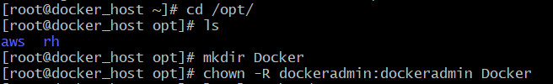



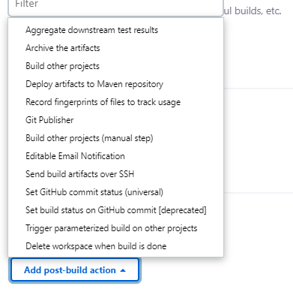

**4) Goto your Jenkins Server**

* In the **Package_code job:**
* In the **configure** go **to post build actions**
* Select **send build artifacts over ssh**

In the **ssh publisher** provide the name of ssh server as **Dockerhost** as mentioned below image

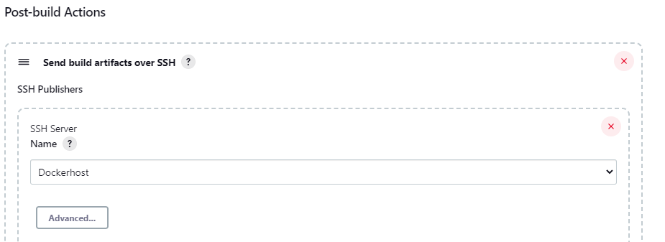

After that in the **Transfers**

1. **source file:** provide the location where our target/*.war file exist.
2. **Remove prefix:** we want to only a kind of file that .war so we will copy on docker so remove /target as prefix
3. **Remote directory :** Provide the where our war file we want to copy and that **is Docker directory** we need to give double slash for or copying file otherwise it will not copy.

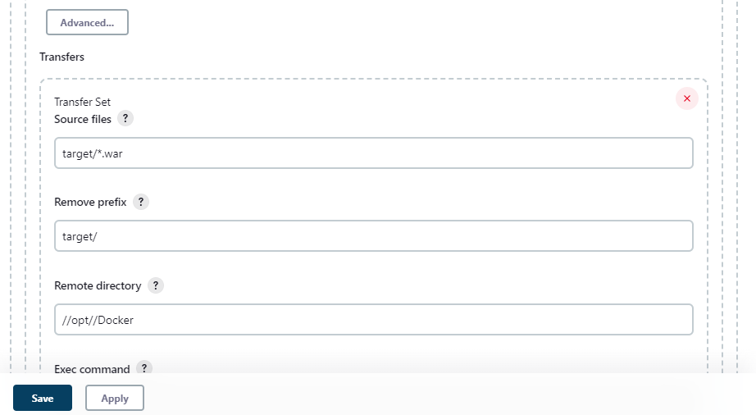

Click on **save** button and build the job it will give following build output

If our success it will give output as a build success and show how many files are transfer during ssh connection. In the console output we can see that how many file get transfer during ssh connection with docker host and closing connection after file get transfer

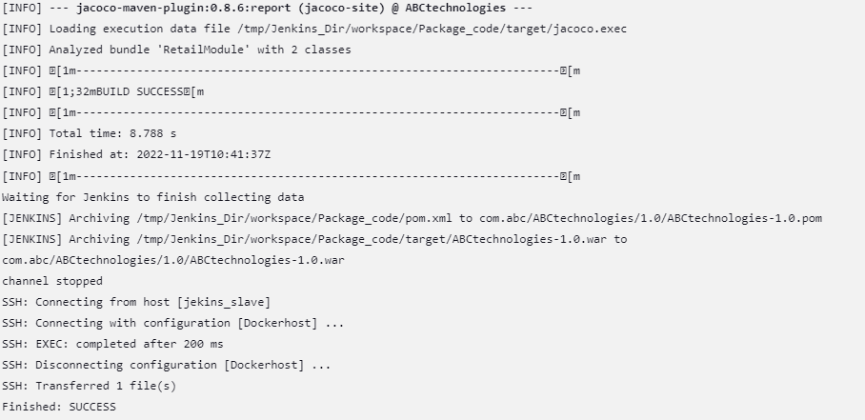

Then go to your docker host machine login as **dockeradmin** user go to **/opt/Docker** directory to check whether our ABCtechnologies-1.0.war file get copied or not.

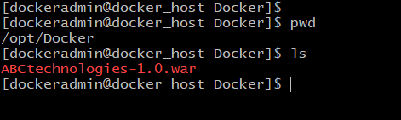

**4)To create an image and container using Dockerfile :**

For creating an image we need a docker file .To write a **Dockerfile** we are using **Tomcat server 9.0** for deploying a war file on webapps directory.

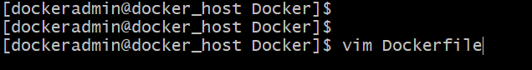

Write the docker file as mention in the image below and save it on /opt/docker directory

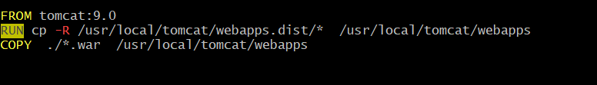

Save the file and come out from the file .

**5) Goto jenkins server of Package job of configure section :**

In post build action option >> In exec command option type following command

**# cd /opt/Docker**

**# docker stop $(docker ps -a -q)**

**# docker rm $(docker ps -a -q)**

**# docker rmi -f tomcat:ver1**

**# docker build -t tomcat:ver1 .**

**# docker run -d --name tomcat_cont -p 8084:8080 tomcat:ver1**

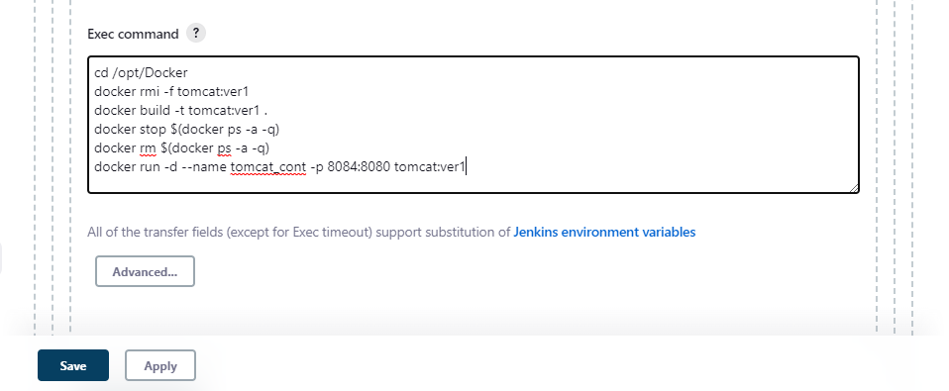

You can create new job to build and deploy on docker container, I am using the same package job for creating images and deploy on container .

Save the Jenkins job before building the job go to your docker host machine and check whether any image is created or any images available on topper host machine

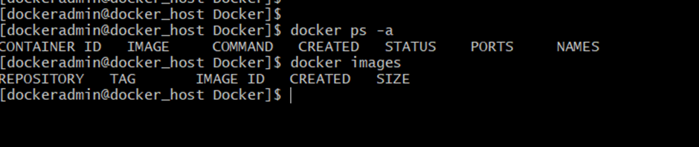

As shown in the screenshot there is no image and no container is created so we will build the job to create an image and container on docker host machine it will give following build output

After build is success, it will be build output as shown in screenshot.

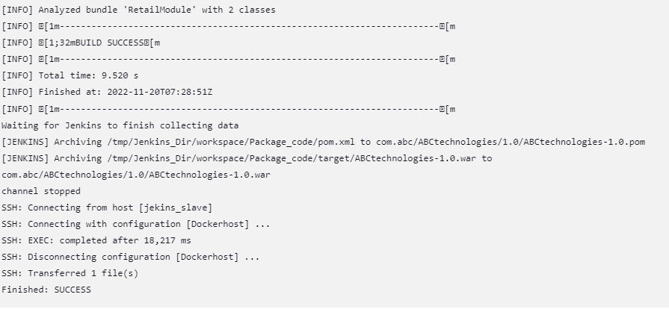

Again goto Docker host check whether image or container is created or not

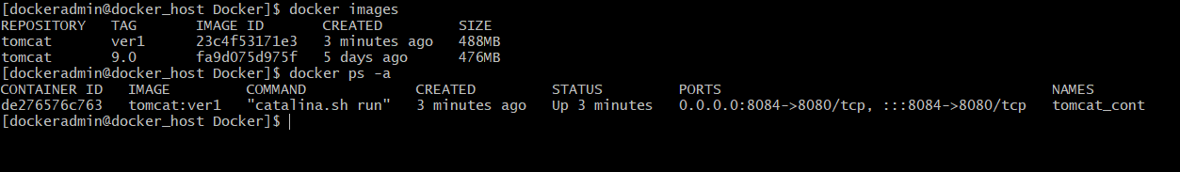

Our image and container gets successfully created

Now check whether our ABCtechnologies-1.0.war is deployed on tomcat server for that goto aws EC2 dashboard copy the public IP of docker host machine

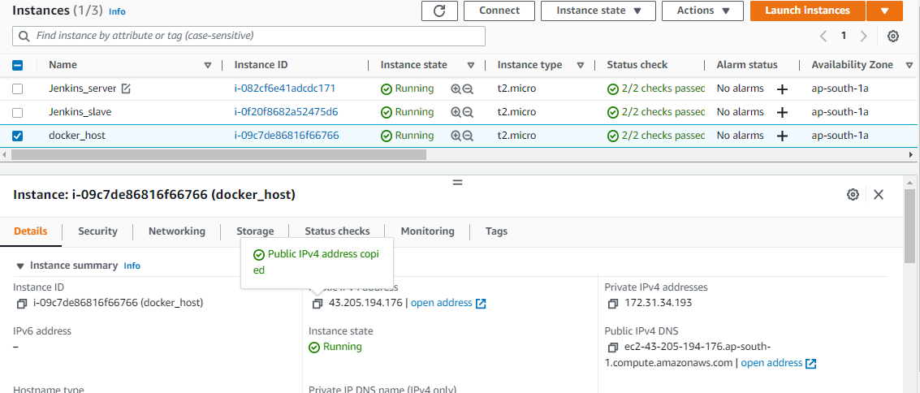

Paste it on browser as public _ip:8084 the container is running on 8084 port it will show tomcat home page

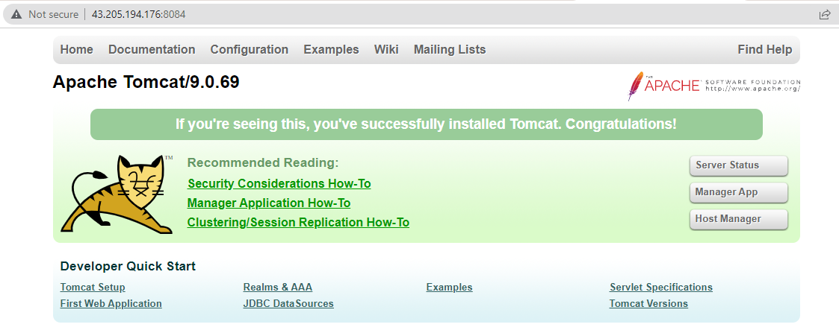

To access our application give your application name as ABCtechnologies-1.0

So the link will be <http://43.205.194.176:8084/ABCtechnologies-1.0/>

